**Assignment 2:**

**Q.N1:** Implement the data link layer framing method “Byte Count”.

**Client:**

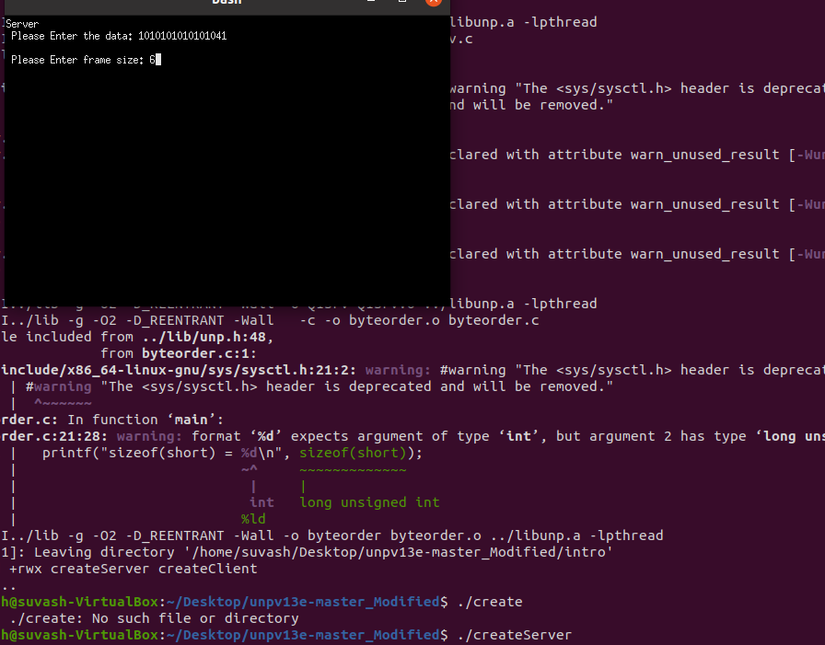

**Server:**

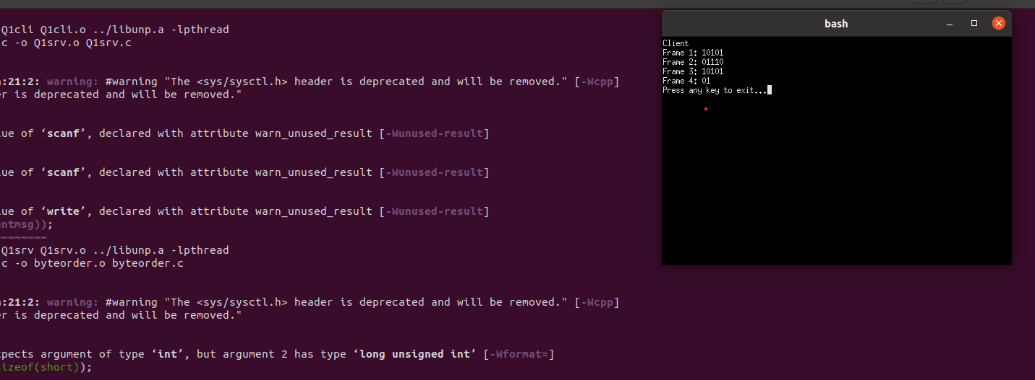

**Q2:** **A k-bit stream is transmitted by the sender using the standard Cyclic Redundancy Check (CRC) method. The generator polynomial is xm+ x + 1, where m <k. Show the actual bit string transmitted. Suppose that the one bit in the bit stream is inverted during transmission. Show that this error is detected at the receiver’s end.**

**Client:**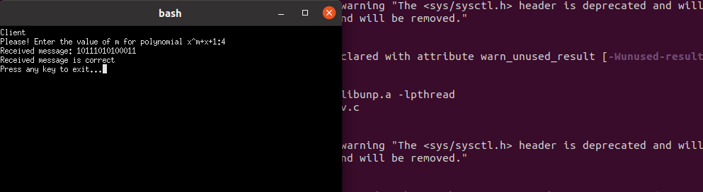

**Server:**

